(Approx. 560 words)

Set Up a Format for Dates in Excel
By Nancy DeMarte, 2nd Vice President,
Sarasota Technology Users Group, FL
August 2018 issue, STUG Monitor
www.thestug.org / ndemarte (at) verizon.net

Excel is a great application to use for creating chronological lists, like a history of when you made major household purchases, or a record of when you visited various cities or countries. By inserting a column of dates, you will be able to sort and re-sort your list by date any time. Inserting dates with a consistent format can seem difficult. Here are some tips to make your dates look the way you want them.

1. Pre-format your cells Open a blank Excel worksheet and enter some headings, including Date, in the row below the column header (C in the illustration). You can select the column that will contain dates by clicking the header to select the whole column, but more likely you will want to select a fewer number of cells. Do this by clicking the green square in the bottom right of the top blank cell (as shown) and drag down the column to select as many cells as you need. You can always pre-format more cells later, if necessary.
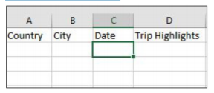
Next, with the cells selected, press Ctrl+1 on your keyboard (Control+1 or Command + 1 for a Mac) to open the Format cells dialog box. Click the Number tab at the top, then click Date under Category to show a list of the 15 – 20 date formats Excel includes. Click the format you want, followed by OK. Now when you type a date using any format into one of the pre-formatted cells, it will appear in the format you have chosen.
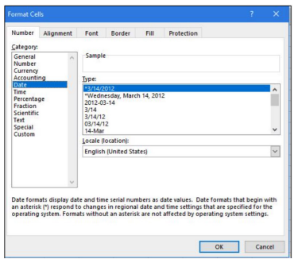
2. Create a custom date format If you don’t find the exact format you want for dates, you can create a new format. Open the Format Cells box as described above. Click the Number tab, then click Custom in the Category list. This reveals a new list of formats. Scroll down until you find the date codes: y = year, m = month, and d = day. Click a Date format that is somewhat close to the one you want to create. Now you can edit it in the box below Type by changing the code letters to fit the format you want. For example, if you want to display dates as year/month/day, you might type yyyy-mm-dd, which will appear as 2018/08/22. You can include times, too, by using the hours:minutes:seconds AM/PM codes.
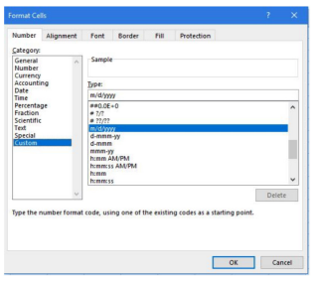
Tips:
1. To remove a date format, select one or more preformatted cells, press Ctrl+1, and select Text in the Category list. The cells will revert to unformatted numbers instead of the date format.

2. To remove all formatting from any Excel cells, on the Home tab> Editing group, click Clear. (It resembles an eraser.). This removes the formatting, but not the content.

3. If you choose a date format that is wider than its column, you might see ##### in the cell. Widen the column by dragging the right column border in the column header to the right until the whole date appears.

4. To enter the current date in an Excel worksheet, select any cell and press Ctrl + semi-colon on the keyboard. It is wise to include the date you created the worksheet to distinguish it from later versions of the sheet.

